Step 1: Installing Myro-C++ and Connecting to the Scribbler

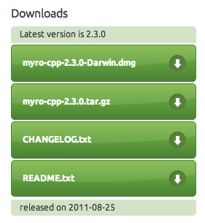
For Mac

1. Installing Myro-C++
- Download the Myro-C++ software,
myro-cpp-2.3.0-Darwin.dmg,
from https://launchpad.net/myro-c++.
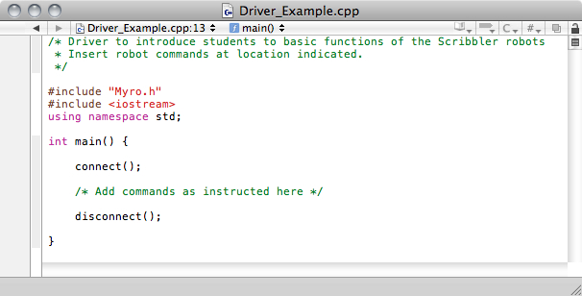
- Run the installer.

2. Connecting to the Robot
  - We’re going to write a short program to connect to the robot, make it beep, and give it a name.

  - Download the sample code, Driver.cpp, from (insert URL here).

  - Now we’re going to edit the driver. Open the file, and examine the existing lines.

  - We need to add code to make the robot beep, and to give it a name. We will be using the Myro commands
robot.beep( duration, frequency ) – beep at a given frequency for a given duration in seconds
robot.setName( “name” ) – give the robot a name
robot.getName( ) – return the robot’s name
as well as the C++ command cout, which prints to the main screen.

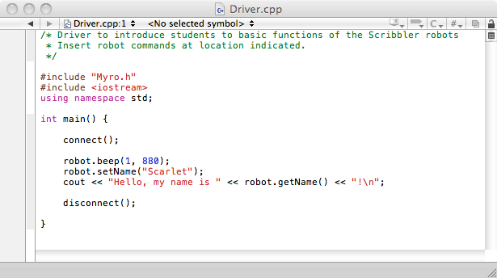
- Edit your driver to resemble the finished one below. Feel free to vary the frequency at which the beep is played, and of course give your robot a unique name!

- Now it’s time to compile your program! Open a window in Terminal, and navigate to the file where your driver is saved.

- Enter the following command, making sure to enter the arguments exactly as they are written here.

g++ ‘myro-cpp-config --cflags --libs’ Driver.cpp –o Driver

- Compile the program, then run it. If your program has worked, you should hear a high-pitched beep from the robot, and the given name will be printed to the command window.

