MIXED  REALITY  ROBOTICS | Infrared Sensors

The Pleo has multiple infrared sensors on its body. These sensors allow the robot to detect and interact with other Pleos, leaves and other external objects.
One infrared transmitter and receiver is located on the top of the Pleo’s nose. One infrared interrupter is located inside of the Pleos mouth which allows it to detect when an object (for example the leaf) has been placed in the mouth.
These infrared sensors can sense other Pleos as well as objects in the mouth based on whether or not the Pleo has a specialized reaction that it will perform. For example, the infrared sensors in the mouth can sense a leaf and establish a grip. This is how the Pleo can play tug-of-war.
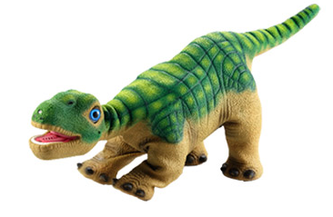
SENSOR_IR

SENSOR_MOUTH

Relevant Sensor: SENSOR_IR
This sensor is used to indicate reception of valued NEC-format IR data that shows something other than another Pleo or a leaf have been detected. The value of this sensor is the number of lines of data in the Infrared receive buffer. The sensor triggers a value of “1” if any data has been received by the infrared sensor and a “0” if nothing has been received.
Relevant Sensor: SENSOR_MOUTH
This sensor indicates the presence or absence of an infrared-opaque object in Pleo’s mouth, such as the leaf. This sensor returns a value of “1” when an object is sensed in the mouth and a value of “0” when no objects are sensed in the mouth.
Relevant Sensor: SENSOR_BEACON
This sensor is used to indicate other Pleo’s and their interaction and is triggered when a beacon is received from another Pleo. The sensor returns a value of “1” when another Pleo is detected and a value of “0” when another Pleo is not detected.
Relevant Sensor: SENSOR_IR_ACTIVITY
This sensor interprets any code that attempts to program the Pleo’s actions and reactions.

