MIXED  REALITY  ROBOTICS | Camera

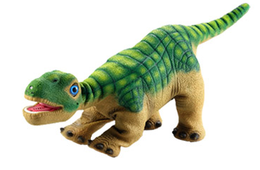
The Pleo robot comes equipped with a color camera located just above the mouth, on the nose. This allows the Pleo to detect changes in light, different colors and, also, motion.

The on board Pleo camera also takes pictures in QCIF format, which is 176x144 pixels. The image is able to be saved in either .bmp or .raw formats.

Terminal Command: to test the camera and capture an image enter…
camera capture <filename> [bmp|raw] [new|last]

For example, camera capture test.bmp takes a picture and stores it as “test.bmp”. However, the camera is sometimes unreliable and a blank image can occur after issuing the command to take a picture.

Images from the Pleo are saved to the SD card, which means that it is impossible to extract and analyze them in real time. There is also no way to stream live video.

However, it is possible to use PAWN code for blob tracking. In order to do this, the code must first be written in PAWN and then compiled and loaded onto an SD card ahead of time. It would be very challenging to implement any blob tracking or optical character recognition in C++ using the on board camera, as any C++ solution would basically need to “trigger” a PAWN command to track images. It is not possible to pass parameters such as colors or shapes to the PAWN script in real time.

In summary, it is not possible to view real-time camera output from the on board camera in C++. But, the on board camera can definitely be utilized.

Relevant Sensor: SENSOR_LIGHT
This sensor indicates the current absolute ambient light level that the Pleo’s camera module detects. The sensor value range is 0-255 and triggers when the value crosses 30 and 150 in either direction - lower values indicate darker areas and higher values indicate light areas.

Relevant Sensor: SENSOR_LIGHT_CHANGE
This sensor detects relative changes to the current light level. The value of the sensor can fall between -127 and 127. The sensor is triggered when the value becomes greater than 30 (the light gets brighter) or when the value becomes less than 30 (the light gets darker).

