MIXED  REALITY  ROBOTICS | Sound and Speaker Sensors

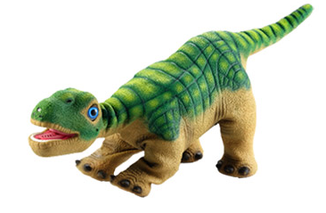
SENSOR_LEFT_LOUD
The Pleo has two microphones on its head – on the right and the left side that appear as small holes - which allow noise to be detected.

Pleo has two speakers – one located in the mouth and on just above the tail. These speakers allow the robot to converse with noise.

SENSOR_RIGHT_LOUD

Pleo already comes with some pre-programmed sounds. But, you can record your own sounds to play from the Pleo. This can be done through the MySkit Wave sound editor.

Terminal Command: to gain more access to commanding Pleo’s sound bank…
help sound

This command will give access to many different sound commands, sound titles available on the Pleo and ways to adjust the sound aspects.

The sound library has a sound called “moo”. For example, if you enter in play sound moo into the terminal, the Pleo will make the “moo” sound.

Relevant Sensor: SENSOR_SOUND_DIR
This sensor triggers when a definite sound is detected. It returns the direction in degrees relative to the Pleo where the sound was heard. A value lower than 90 means that the sound was detected to the left of the Pleo and a value greater than 90 means that the sound was detected to the right of the Pleo, while a value of 0 means that the sound was straight ahead. A loud sound with no direction changes the value to -128. Pleo is best at recognizing long sounds, as it gives the sensor more time to find a pattern and decipher the sound.

Relevant Sensor: SENSOR_SOUND_LOUD
This sensor detects the edges of loud sounds that stand out from background sound levels. The sensor triggers when the value of the volume of the sound is greater than “40” or becomes less than “30”. The value range is between 0 and 100.

Relevant Sensor: SENSOR_LOUD_CHANGE
This sensor is used to detect large changes in ambient noises based on the long-term average noise level which is monitored. The sensor value is the difference between the short-term detected noise level and the long term average level. A value between -127 and 127 will be returned by this sensor. In the example below, the Pleo heard a sound that was a value of 16 greater than the average sound level of its current environment.

Relevant Sensor: SENSOR_LEFT_LOUD
This sensor returns the absolute loudness of the left microphone. In the example below, this Pleo is hearing a sound with the volume value of 60 with the left microphone.

Relevant Sensor: SENSOR_RIGHT_LOUD
This sensor returns the absolute loudness of the right microphone. In the example, the robot, the same Pleo from the example, above is hearing a sound with the volume of 28 with the right microphone.

