MIXED  REALITY  ROBOTICS | Motors and Joints

There are 14 motors located all over the Pleo. These motors give the robot the ability to walk, wag its tail and crane its neck. All of these motors have force feedback sensors, so they are able to detect the environment surrounding the Pleo.

All of the motors already exist in the Pleo and the robot comes pre-programmed with some natural movements that the Pleo does on its own in a natural environment. However, because the motors move wires in the robot in response to instructions from processors, it is also possible to program more complex and unique movements that utilize these motors.

Pleo’s motors allow the robot to generate purposeful actions which often relay emotion. These movements can be in response to touch or a stimulus. Alternatively, Pleos can be programmed to do movements without any trigger.
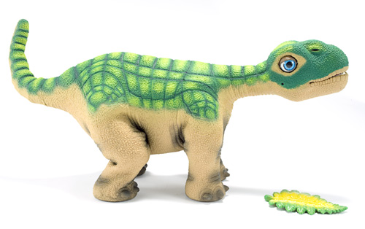

Head
This motor is at neutral position, when the Pleo is looking straight ahead. Otherwise, the robot can look 90 degrees up and 90 degrees down.
Neck (Horizontal)
The neutral position is straight forward. The neck can, also, move 65 degrees left and right.
Tail (Vertical)
Neutral position is straight back. Otherwise, the tail can move 90 degrees up and 90 degrees down.
Tail (Horizontal)
Neutral position is straight back. Otherwise the tail can move 90 left and 90 degrees right.
Neck (Vertical)
This motor is at neutral position, when the Pleo is looking straight ahead. The neck can, also, move 75 degrees up or down.

Elbows (2)
Straight is the neutral position for this motor. The elbow motor can only move 30 degrees forward from the neutral state.
Shoulders (2)
Straight is the neutral position for this motor. It can also move 55 degrees forward from the neutral and state and 20 degrees backwards.

Knee (2)
The neutral state for this motor is straight down. The motor can also rotate 50 degrees backwards from the neutral state.
Torso
The neutral position is straight forward. The motor can move 35 degrees left and right.
Hips (2)
The neutral state for this motor type is straight down. The motor can, alos, move 45 degrees forwards and backwards.

Terminal Command: in order to control the movements of Pleo enter:
help joint

This command will give access to more ways of commanding the Pleo. For example, if joint neutral is entered into the terminal, the Pleo will move all of its joints to neutral position. The terminal will return the progress of each joint during the process of returning to neutral position.

Relevant Sensor: SENSOR_TILT
This sensor detects the orientation of Pleo’s torso in three spaces and is triggered when the title sensor moves into a new position. The sensor can return these values…
TILT_NONE = 0 (no orientation known)
TILT_ON_FEET = 1 (feet are oriented downwards with respect to torso)
TILT_LEFT_SIDE = 2 (on left side)
TILT_RIGHT_SIDE = 3 (on right side)
TILT_ON_NOSE = 4 (front of torso is pointed downwards)
TILT_ON_TAIL = 5 (aft-end of torso is pointed upwards)
TILT_ON_BACK = 6 (feet are pointed upwards with respect to torso)
Relevant Sensor: SENSOR_SHAKE
This sensor is used to detect if the Pleo is being shaken, like, for example, when it is being woken up. The value of this sensor can be between 0 and 255. The sensor triggers when the shake frequency goes from below 75 to above 150.
______________________________________________________________________________

Another easy way to control and create new movements for the Pleo is through a program called MySkit. This is very easy to use, and is basically a GUI that lets you set a routine of sound and movement for the Pleo. You then “compile” your skit and upload it to a SD card which you plug into the Pleo. When starting up, the Pleo first checks the SD card for any programs before it boots into normal routines.

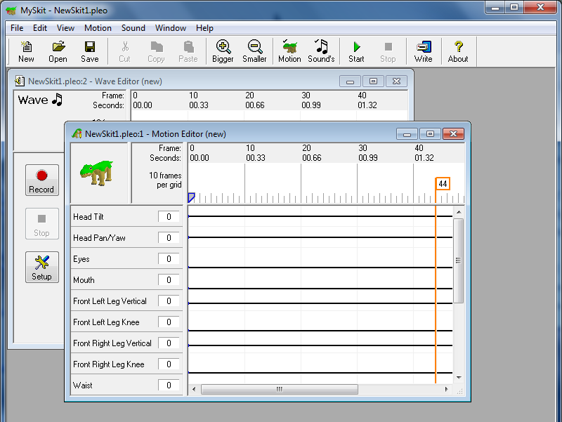

Motions can be activated by connecting to Pleo via a terminal and typing the following command:
motion play (Motion number)

So, for example, the code for walk forward is 8330. To make Pleo walk forward, enter “motion play 8330” into the terminal and the robot will walk forward. For a list of all available motions, type the command “motion show”.

Emotions that Pleo Motions evoke:

Happy | Sad | Tired
motion ID 8320 = com_tail_wag  motion ID 8321 = com_tail_wag_v2  motion ID 8322 = com_tilt_back_tickle_la  motion ID 8323 = com_tilt_back_tickle_ll  motion ID 8324 = com_tilt_back_tickle_ra  motion ID 8325 = com_tilt_back_tickle_rl  motion ID 8343 = emo_act_happy_v1  motion ID 8344 = emo_act_happy_v2  motion ID 8407 = happy_honk  motion ID 8354 = emo_fidget_happy_v1  motion ID 8355 = emo_fidget_happy_v2 | motion ID 8467 = soc_abuse_whimper  motion ID 8345 = emo_act_sad_v1  motion ID 8346 = emo_act_sad_v2  motion ID 8393 = fat_nap_fidget_pain  motion ID 8394 = fat_nap_fidget_sad  motion ID 8395 = fat_nap_fidget_scared  motion ID 8264 = com_disappointed_v1  motion ID 8265 = com_disappointed_v2  motion ID 8266 = com_fallen_l_breath_v1  motion ID 8267 = com_fallen_l_breath_v2  motion ID 8268 = com_fallen_tilt_l_in  motion ID 8269 = com_fallen_tilt_l_loop_v1  motion ID 8270 = com_fallen_tilt_l_loop_v2  motion ID 8271 = com_fallen_tilt_l_sleep  motion ID 8272 = com_fallen_tilt_r_in  motion ID 8273 = com_fallen_tilt_r_loop_v1  motion ID 8274 = com_fallen_tilt_r_loop_v2  motion ID 8275 = com_fallen_tilt_r_sleep  motion ID 8356 = emo_fidget_pain_v1  motion ID 8357 = emo_fidget_sad_v1  motion ID 8358 = emo_fidget_scared_v1  motion ID 8347 = emo_act_scared_v1  motion ID 8348 = emo_act_scared_v2 | motion ID 8482 = soc_rest_fidget_v1  motion ID 8483 = soc_rest_fidget_v2  motion ID 8484 = soc_rest_fidget_v3  motion ID 8485 = soc_rest_fidget_v4  motion ID 8486 = soc_rest_laydown  motion ID 8487 = soc_rest_listen  motion ID 8488 = soc_rest_pant  motion ID 8489 = soc_rest_pant_v1  motion ID 8490 = soc_rest_pose_v1  motion ID 8491 = soc_rest_rxn_head  motion ID 8492 = soc_rest_rxn_tail  motion ID 8493 = soc_rest_sniff  motion ID 8566 = yawn_3  motion ID 8396 = fat_nap_fidget_sniff  motion ID 8397 = fat_nap_fidget_sound  motion ID 8398 = fat_nap_fidget_v1  motion ID 8399 = fat_nap_fidget_v2  motion ID 8400 = fat_nap_getup  motion ID 8401 = fat_nap_getup_v2  motion ID 8402 = fat_nap_getup_v3  motion ID 8403 = fat_nap_lay_down  motion ID 8404 = fat_sleep_lay  motion ID 8405 = fat_tired  motion ID 8406 = fat_yawn
Angry | Hungry | Miscellaneous
motion ID 8337 = emo_act_angry_v1  motion ID 8338 = emo_act_angry_v2  motion ID 8350 = emo_fidget_angry_v1  motion ID 8351 = emo_fidget_angry_v2  motion ID 8462 = picked_up_shake  motion ID 8463 = picked_up_squirming  motion ID 8464 = singing_howling  motion ID 8465 = soc_abuse_head_chin  motion ID 8466 = soc_abuse_rxn  motion ID 8565 = upside_down  motion ID 8388 = fat_nap_fidget_angry  motion ID 8364 = exp_object_react_growl | motion ID 8412 = hun_baby_bird_feeding  motion ID 8413 = hun_beg  motion ID 8414 = hun_bite_s  motion ID 8415 = hun_chew_drop  motion ID 8416 = hun_chew_drop_stuck  motion ID 8417 = hun_chew_fast  motion ID 8418 = hun_chew_slow  motion ID 8419 = hun_chew_v1  motion ID 8420 = hun_dropped_sniff  motion ID 8421 = hun_exit  motion ID 8422 = hun_expecting  motion ID 8423 = hun_fidget_scratch_left  motion ID 8424 = hun_graze_big_bites  motion ID 8425 = hun_graze_drink  motion ID 8426 = hun_graze_ripping  motion ID 8427 = hun_graze_stand  motion ID 8428 = hun_graze_v1  motion ID 8429 = hun_graze_v2  motion ID 8430 = hun_graze_v3  motion ID 8431 = hun_happy_graze  motion ID 8432 = hun_happy_honk  motion ID 8433 = hun_hatch_bird  motion ID 8434 = hun_hatch_bird_whimper  motion ID 8435 = hun_hatch_cry_down  motion ID 8436 = hun_hatch_cry_inward  motion ID 8437 = hun_hatch_cry_up  motion ID 8438 = hun_hatch_tantrum_A  motion ID 8439 = hun_hatch_tantrum_B  motion ID 8440 = hun_lip_smack  motion ID 8441 = hun_moo  motion ID 8442 = hun_paw_ground_l  motion ID 8443 = hun_paw_ground_r  motion ID 8444 = hun_rxn_back  motion ID 8445 = hun_rxn_chin  motion ID 8446 = hun_rxn_head  motion ID 8447 = hun_rxn_la  motion ID 8448 = hun_rxn_ra  motion ID 8449 = hun_search  motion ID 8450 = hun_sniff_l  motion ID 8451 = hun_sniff_r  motion ID 8452 = hun_sniff_s  motion ID 8453 = hun_sniff_stand_ground  motion ID 8454 = hun_sniff_walk_air  motion ID 8455 = hun_stand  motion ID 8456 = hun_stand_chewing_cud  motion ID 8457 = hun_stand_looking  motion ID 8458 = hun_stand_sniff_ground  motion ID 8459 = hun_tantrum_for_food  motion ID 8460 = hun_tummy_rumble  motion ID 8461 = hungry_cry | motion ID 8349 = emo_fidget_affect_v1  motion ID 8352 = emo_fidget_bored_v1  motion ID 8353 = emo_fidget_curious_v1  motion ID 8359 = exp_in  motion ID 8360 = exp_object_gone  motion ID 8361 = exp_object_react_bark  motion ID 8362 = exp_object_react_bite  motion ID 8363 = exp_object_react_curious  motion ID 8339 = emo_act_bored_v1  motion ID 8340 = emo_act_bored_v2  motion ID 8341 = emo_act_curious_v1  motion ID 8342 = emo_act_curious_v2  motion ID 8408 = hatch_coax_walk1  motion ID 8409 = hatch_coax_walk2  motion ID 8410 = hatch_reward  motion ID 8411 = hiccup  motion ID 8276 = com_fidget_cough  motion ID 8277 = com_fidget_sneeze  motion ID 8278 = com_hatch_twitchy_stand  motion ID 8279 = com_head_held_v1  motion ID 8280 = com_hello_bark_lg  motion ID 8281 = com_hello_bark_sm  motion ID 8282 = com_hello_howl  motion ID 8283 = com_hello_playfight  motion ID 8284 = com_holding_fidget_l_v1  motion ID 8285 = com_holding_fidget_l_v2  motion ID 8290 = com_holding_l  motion ID 8291 = com_holding_pre_l  motion ID 8292 = com_holding_r  motion ID 8293 = com_light_off_v1  motion ID 8294 = com_light_on_v1  motion ID 8295 = com_listen_s  motion ID 8296 = com_obj_detect_l  motion ID 8297 = com_obj_detect_r  motion ID 8298 = com_obj_detect_s  motion ID 8299 = com_puke  motion ID 8300 = com_rxn_buck  motion ID 8301 = com_rxn_buttup  motion ID 8302 = com_rxn_dizzy  motion ID 8303 = com_rxn_howl  motion ID 8304 = com_rxn_lite_off  motion ID 8305 = com_rxn_lite_on  motion ID 8306 = com_rxn_tickle  motion ID 8307 = com_shat  motion ID 8308 = com_sit  motion ID 8309 = com_sneeze_v1  motion ID 8314 = com_sniff_neutral_l_v2  motion ID 8318 = com_tail_held_v1  motion ID 8319 = com_tail_held_v2  (and many more… )

