MIXED  REALITY  ROBOTICS | Motors and Joints

There are 14 motors located all over the Pleo. These motors give the robot the ability to walk, wag its tail and crane its neck. All of these motors have force feedback sensors, so they are able to detect the environment surrounding the Pleo.

All of the motors already exist in the Pleo and the robot comes pre-programmed with some natural movements that the Pleo does on its own in a natural environment. However, because the motors move wires in the robot in response to instructions from processors, it is also possible to program more complex and unique movements that utilize these motors.

Pleo’s motors allow the robot to generate purposeful actions which often relay emotion. These movements can be in response to touch or a stimulus. Alternatively, Pleos can be programmed to do movements without any trigger.
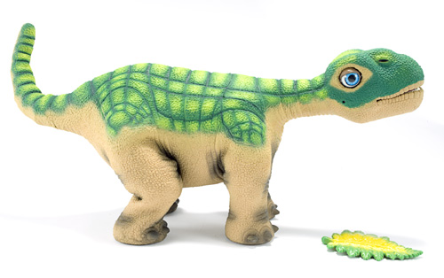

Head
This motor is at neutral position, when the Pleo is looking straight ahead. Otherwise, the robot can look 90 degrees up and 90 degrees down.
Neck (Horizontal)
The neutral position is straight forward. The neck can, also, move 65 degrees left and right.
Tail (Vertical)
Neutral position is straight back. Otherwise, the tail can move 90 degrees up and 90 degrees down.
Tail (Horizontal)
Neutral position is straight back. Otherwise the tail can move 90 left and 90 degrees right.
Neck (Vertical)
This motor is at neutral position, when the Pleo is looking straight ahead. The neck can, also, move 75 degrees up or down.

Elbows (2)
Straight is the neutral position for this motor. The elbow motor can only move 30 degrees forward from the neutral state.
Shoulders (2)
Straight is the neutral position for this motor. It can also move 55 degrees forward from the neutral and state and 20 degrees backwards.

Knee (2)
The neutral state for this motor is straight down. The motor can also rotate 50 degrees backwards from the neutral state.
Torso
The neutral position is straight forward. The motor can move 35 degrees left and right.
Hips (2)
The neutral state for this motor type is straight down. The motor can, alos, move 45 degrees forwards and backwards.

Terminal Command: in order to control the movements of Pleo enter:
help joint

This command will give access to more ways of commanding the Pleo. For example, if joint neutral is entered into the terminal, the Pleo will move all of its joints to neutral position. The terminal will return the progress of each joint during the process of returning to neutral position.

Relevant Sensor: SENSOR_TILT
This sensor detects the orientation of Pleo’s torso in three spaces and is triggered when the title sensor moves into a new position. The sensor can return these values…
TILT_NONE = 0 (no orientation known)
TILT_ON_FEET = 1 (feet are oriented downwards with respect to torso)
TILT_LEFT_SIDE = 2 (on left side)
TILT_RIGHT_SIDE = 3 (on right side)
TILT_ON_NOSE = 4 (front of torso is pointed downwards)
TILT_ON_TAIL = 5 (aft-end of torso is pointed upwards)
TILT_ON_BACK = 6 (feet are pointed upwards with respect to torso)
Relevant Sensor: SENSOR_SHAKE
This sensor is used to detect if the Pleo is being shaken, like, for example, when it is being woken up. The value of this sensor can be between 0 and 255. The sensor triggers when the shake frequency goes from below 75 to above 150.
______________________________________________________________________________

Another easy way to control and create new movements for the Pleo is through a program called MySkit. This is very easy to use, and is basically a GUI that lets you set a routine of sound and movement for the Pleo. You then “compile” your skit and upload it to a SD card which you plug into the Pleo. When starting up, the Pleo first checks the SD card for any programs before it boots into normal routines.
