Summer 2012
University of Southern California | Professor Sheila Tejada

Mixed Reality Robotics | Pleo ToolKit – Programming in C++

MIXED REALITY  ROBOTICS | Table of Contents

Introduction to the Pleo……………………………………………………… 4
- Pleo Behavior 5
- Sensor Descriptions
Camera 7
Touch Sensors X
Motors X
Sound and Speakers X
Infrared Sensors X
- Understanding Sensor Readings X
- Battery Overview X

Pleo and Operating Systems.………………………………………………… X
- Windows 7 (32 bit) X
- Windows 7 (64 bit) X
- Mac OS X
- Linux X
- Unix X

Programming with Pleo……………………………………………………... X
- Graphical User Interface X
- PAWN X
- C++ X

Getting Started with Coding…………………………………………………. X

Integrating the Pleo into Education…………………………………………. X

Previous Projects…………………………………………………………….. X

MIXED REALITY  ROBOTICS | Introduction to the Pleo

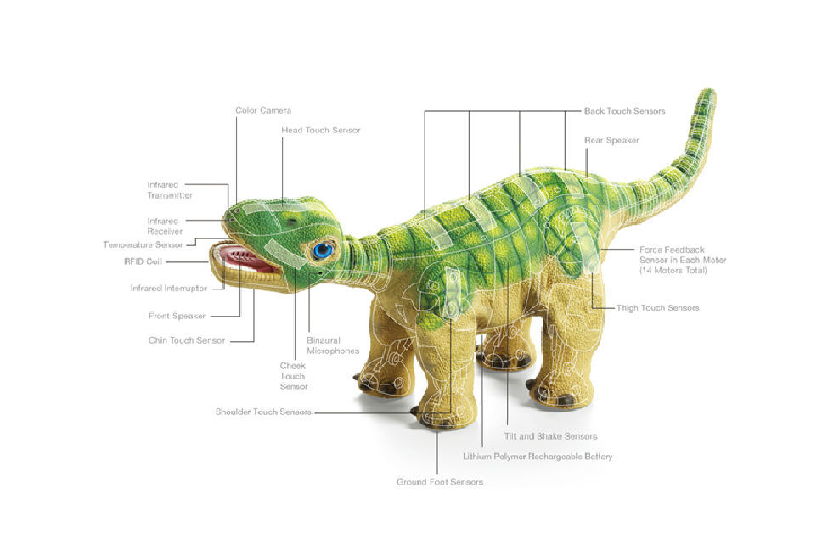

MIXED REALITY  ROBOTICS | Pleo Behavior

MIXED REALITY  ROBOTICS | Pleo’s Camera

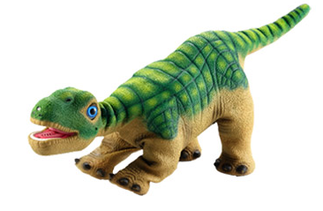
The Pleo robot comes equipped with a color camera located just above the mouth, on the nose. This allows the Pleo to detect changes in light, different colors and, also, motion.

The on board Pleo camera also takes pictures in QCIF format, which is 176x144 pixels. The image is able to be saved in either .bmp or .raw formats.

The command to test the camera and capture an image is:
camera capture <filename> [bmp|raw] [new|last]

For example, camera capture test.bmp takes a picture and stores it as “test.bmp”. However, the camera is sometimes unreliable and a blank image can occur after issuing the command to take a picture.

Images from the Pleo are saved to the SD card, which means that it is impossible to extract and analyze them in real time. There is also no way to stream live video.
An example of an image captured by a Pleo robot

However, it is possible to use PAWN code for blob tracking. In order to do this, the code must first be written in PAWN and then compiled and loaded onto an SD card ahead of time. It would be very challenging to implement any blob tracking or optical character recognition in C++ using the on board camera, as any C++ solution would basically need to “trigger” a PAWN command to track images. It is not possible to pass parameters such as colors or shapes to the PAWN script in real time.

In summary, it is not possible to view real-time camera output from the on board camera in C++. But, the on board camera can definitely be utilized.

MIXED REALITY  ROBOTICS | Pleo’s Touch Sensors

The Pleo comes equipped with eight capacitive touch sensors that seamlessly work together with the skin so it doesn’t feel like you’re pressing a button, but rather just interacting with the robot. They look like thin, metal strips and are located on the robots back, legs, shoulder, head, and chin.

These sensors detect proximity of objects (not touch or pressure), and give the robot a sense of their outside environment, in what way they are being handled and how they should send signals to the motors to move in reaction to the detected input. Ground touch sensors on the bottom of the feet let the Pleo know if it has been picked up, or if it is standing on a solid surface.

A little more technically speaking, the Pleo’s touch sensors are made of foil patches that measure the charge accumulation upon detecting proximity. The transfer of charge between the circuit and the ground plane can then trigger a signal to the Pleo’s microcontroller. (More information on trigger levels can be found in the section “Understanding Sensor Readings”)

MIXED REALITY  ROBOTICS | Pleo’s Motors

There are 14 motors located all over the Pleo. These motors give the robot the ability to walk, wag its tail and crane its neck. All of these motors have force feedback sensors, so they are able to detect the environment surrounding the Pleo.

All of the motors already exist in the Pleo and the robot comes pre-programmed with some natural movements that the Pleo does on its own in a natural environment. However, because the motors move wires in the robot in response to instructions from processors, it is also possible to program more complex and unique movements that utilize these motors.

One of the coolest things about the Pleo robot is that these motors generate movements which allow the Pleo to appear to have purpose in its actions and in many cases can relate emotion. These movements can be in response to touch, or a stimulus, or they just be programmed to do movements without any trigger. Pleo alos has the ability to explore based on its out-of-the-box settings, but also has the ability to be programmed and customized.

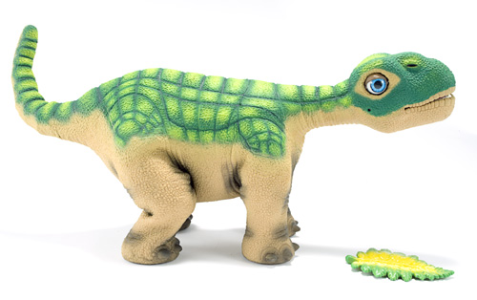

Neck (Vertical)
This motor is at neutral position, when the Pleo is looking straight ahead. The neck can, also, move 75 degrees up or down.
Shoulders (2)
Straight is the neutral position for this motor. It can also move 55 degrees forward from the neutral and state and 20 degrees backwards.

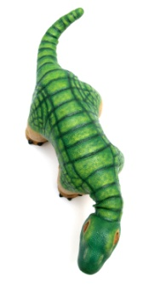
Elbows (2)
Straight is the neutral position for this motor. The elbow motor can only move 30 degrees forward from the neutral state.
Head
This motor is at neutral position, when the Pleo is looking straight ahead. Otherwise, the robot can look 90 degrees up and 90 degrees down.

Neck (Horizontal)
The neutral position is straight forward. The neck can, also, move 65 degrees left and right.
Hips (2)
The neutral state for this motor type is straight down. The motor can, alos, move 45 degrees forwards and backwards.

Neck (Horizontal)
Neutral position is straight back. Otherwise the tail can move 90 left and 90 degrees right.
Tail (Vertical)
Neutral position is straight back. Otherwise, the tail can move 90 degrees up and 90 degrees down.
Knee (2)
The neutral state for this motor is straight down. The motor can also rotate 50 degrees backwards from the neutral state.
Torso
The neutral position is straight forward. The motor can move 35 degrees left and right.
MIXED REALITY  ROBOTICS | Pleo’s Sound Sensors and Speakers

The Pleo has two microphones on its head – on the right and the left side that appear as small holes - which allow noise to be detected.

Pleo has two speakers – one located in the mouth and on just above the tail. These speakers allow the robot to converse with noise.

Pleo already comes with some pre-programmed sounds. But, you can record your own sounds to play from the Pleo.

MIXED REALITY  ROBOTICS | Pleo’s Infrared Sensors

MIXED REALITY  ROBOTICS | Understanding Sensor Readings

