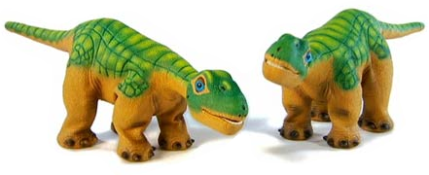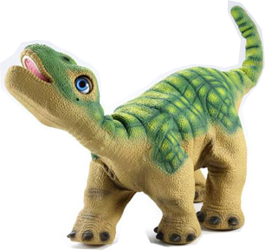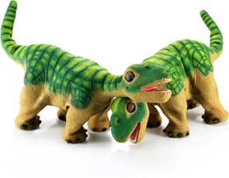

**About Pleo**

* The Pleo is a friendly looking dinosaur robot
* It resembles a Camarasaurus, a large, plant-eating, four-legged dino that lived 150 million years ago
* Pleos can walk, sense objects, respond to touch, eat, sleep, make noises, and read
* Pleo has 14 motors that control its movements- these movements are purposeful and are controlled by Pleos many sensor
* There are touch, light, and sound sensors- additionally there is an infrared transmitter/receiver, two microphones, a color camera, tilt/shake sensors, ground sensors, and force feedback sensors

For more information, please visit  
**www.PleoWorld.com**

**Our Pleos:** Little Foot, Grandpa, Leslie, Marlowe

**How to connect with Pleo from the Mac?**

* **ls /dev/tty.\***
* **/dev/tty.usbmodemfd121 yournumberhere**

| Motion Commands |  |
| --- | --- |
| joint neutral | Pleo will straighten up. |
| motion run 8194 | Step left. |
| motion run 8195 | Angry motion. |
| motion run 8196 | Angry hissing motion. |
| motion run 8197 | Bottom down. |
| motion run 8201 | Baby bird motion. |
| motion run 8204 | Go back three steps. |
| motion run 8209 | Bite motion. |
| motion run 8212 | Blinking motion. |
| motion run 8218 | Mouth motions. |

| Sound Commands |
| --- |
| sound play moo |
| sound play 4494 |
| sound play 4495 |
| sound play 4469 |
| sound play 4486 |
| sound play 4477 |
| sound play godzilla |

Pleo Interaction

How to control Pleo:

1) Join the wireless network "Pleo" from your phone or laptop. There is no password.

2) Go to [192.168.1.100/p](http://192.168.1.100/pleopanel.html)leo.html

3) Click on the action you would like Pleo to do!

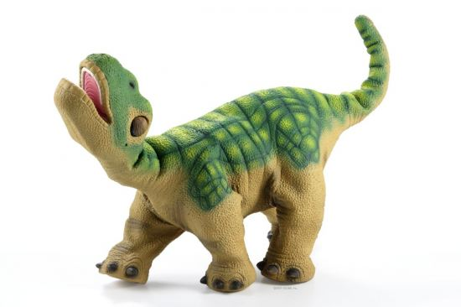  
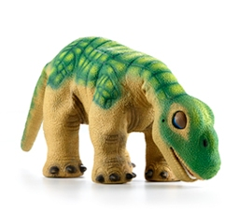 PLEO, the Programming Side:   
 Using Applications and Code

**Motion Editing in My Skit**

MySkit is a Windows Application that allows the user to create motions and synchronized sounds for sue with the PLEO robot.

Using this program, you can create custom PLEO dances & performances. MySkit also allows you to teach PLEO how to recognize images on flash cards.

The program you create for the PLEO is

saved on SD Card and then plugged

into the robot.

This is a really helpful tool in studying

PLEO’s motion abilities, and realistic movements

as well, before transferring the motions to code.

[Work Cited: http://www.dogsbodynet.com/myskit/index.html]

**Motion Editing in My Skit**

MySkit is a Windows Application that allows the user to create motions and synchronized sounds for sue with the PLEO robot.

Using this program, you can create custom PLEO dances & performances. MySkit also allows you to teach PLEO how to recognize images on flash cards.

The program you create for the PLEO is

saved on SD Card and then plugged

into the robot.

This is a really helpful tool in studying

PLEO’s motion abilities, and realistic movements

as well, before transferring the motions to code.

[Work Cited: http://www.dogsbodynet.com/myskit/index.html]

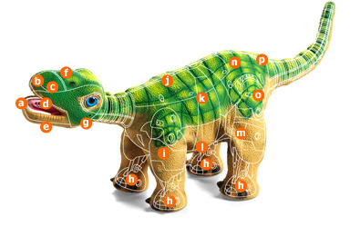

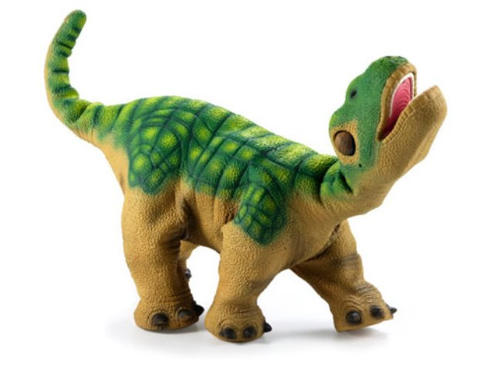

**Programming in PAWN**

*PAWN* is a scripting language which can be use to program PLEO. In PAWN you can write sensor scripts, drive scripts and behavior scripts for the robot. This controls the PLEO’s motions, sounds and motion/sound commands.

The scripts are processed using the PAWN compiler and a post-processing tool to arrange the code in organized code blocks. The saved coded script is compiled and saved on an SD Card, and then inserted into PLEO.

Our test program is an example of a sensor test. Whenever

PLEO is touched, he will make a sound depending on the

sensor touched. This is to help research where each sensor is

located, and to study the trigger levels of each sensor.

(*An outline of each sensor location can be found in the photo in the middle of the page*).

[Work Cited: <http://www.pleoworld.com/downloads/PawnScriptingInLifeOS.pdf>]